What are values?
Values are basic and fundamental beliefs that guide or motivate attitudes or actions. They help us to determine what is important to us. Values describe the personal qualities we choose to embody to guide our actions; the sort of person we want to be; the manner in which we treat ourselves and others, and our interaction with the world around us. They provide the general guidelines for conduct.

Attitudes refer to the way a person expresses their values through their behaviour and words.

Values: | Negative attitudes: | Positive attitudes:
- Fairness  - Honesty  - Freedom  - Dignity  - Community/public safety  - Health  - Education  - Financial security  - World peace  - Justice/Law  - The environment  - Family  - Social connection  - Respect  - Personal safety  - Happiness  - Mental Health  - Physical Health  - Freedom of speech  - Human rights  - Animal rights | - Aggressive  - Arrogant  - Belligerent  - Bigoted  - Blunt  - Careless  - Callous  - Critical  - Cynical  - Dishonest  - Distant  - Envious  - Greedy  - Guarded  - Hostile  - Indifferent  - Intolerant  - Irresponsible  - Jealous | - Interested  - Humorous  - Hopeful  - Sympathetic  - Self-assured  - Happy  - Carefree  - Romantic  - Reverent  - Respectful  - Relaxed  - Reassuring  - Proud  - Poignant  - Playful  - Placid  - Casual  - Calm  - Fun  - Approving  - Passionate  - Optimistic
For instance, if someone is driving dangerously, it’s likely they do not value ________________________.
And if they are driving dangerously, they are demonstrating a _____________________ attitude towards others.
Or if I volunteer at the RSPCA, my values are likely _________________________ and _______________.
At the RSPCA, I always show an interested and respectful attitude towards the animals and other volunteers.
I value the environment, and this is evident when I pick up rubbish.
But Betsy might not value the environment because I sometimes see her litter, which shows her __________________ attitude.
Over to you. Finish these sentences:
Something I value in my life is ____________________________________________________________...
…and this is evident when I _______________________________________________________________.
What do we mean by ‘cultural assumption’?
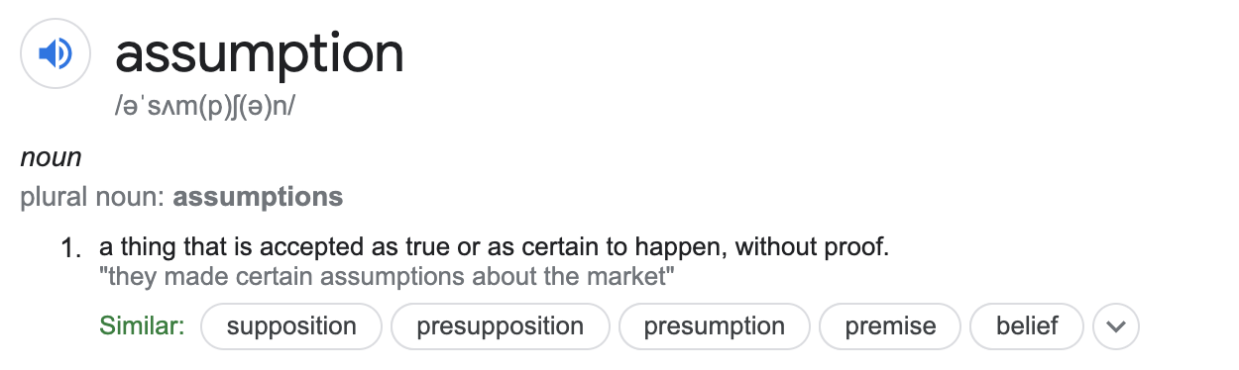
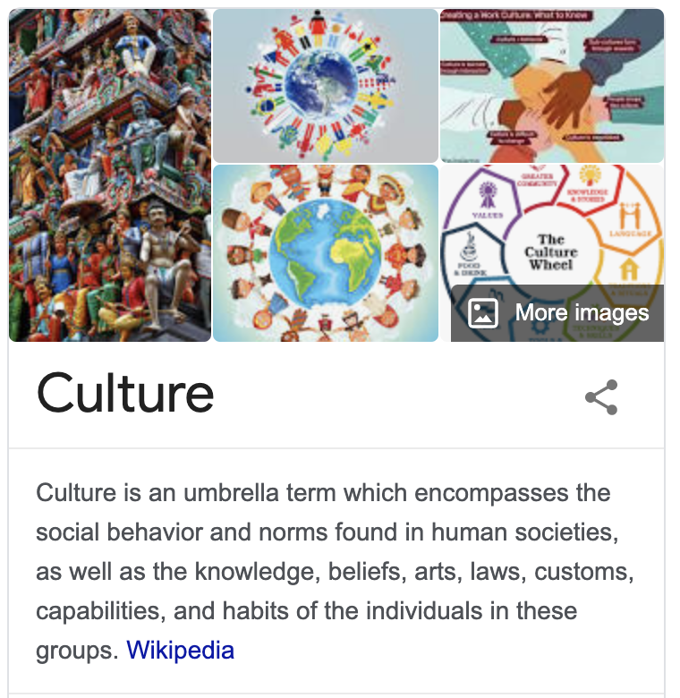

A cultural assumption about girls is that they like pink.
A cultural assumption about boys is that they love footy.
A cultural assumption about Australian’s is that they ____________________________.
A cultural norm in Australia is that we believe in a fair go for all.
Finally, what do we mean by ‘representations’?
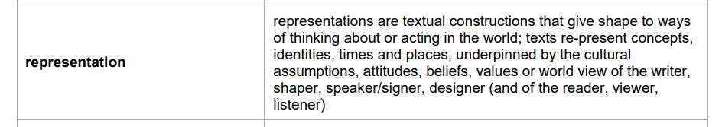
From the syllabus…but what the heck does this mean?
Essentially, we just mean the idea being communicated in the text – whether it’s an image or writing.
Let’s try:


One representation of Schoolies is…

A second representation of Schoolies is…

A cultural assumption is…

A value being communicated about Schoolies is…

